Decision Making

# Directions

Complete the simulation found on the Assignment Manager page on the Pearson site and answer the questions below.

* Use ExcelOM for each of the grades of gasoline
* Use Moving Average forecasting template
  + Setup for 30 periods
  + Include the Graph and Tracking signal options

# Questions

1. What was the resulting MAPE for overall, regular, mid-grade, and premium? Was any grade more difficult to track?
2. How was the expert advice used? How was it decided when to use the advice?
3. What impact did using the ExcelOM template have on the ability to forecast? How would the accuracy have changed without it?
4. How was the forecast changed for any unplanned events?
5. Were the goals reached for the simulation? If not, how could it have been improved? If yes, then what was done that led to the success?

# Overview

## Setup

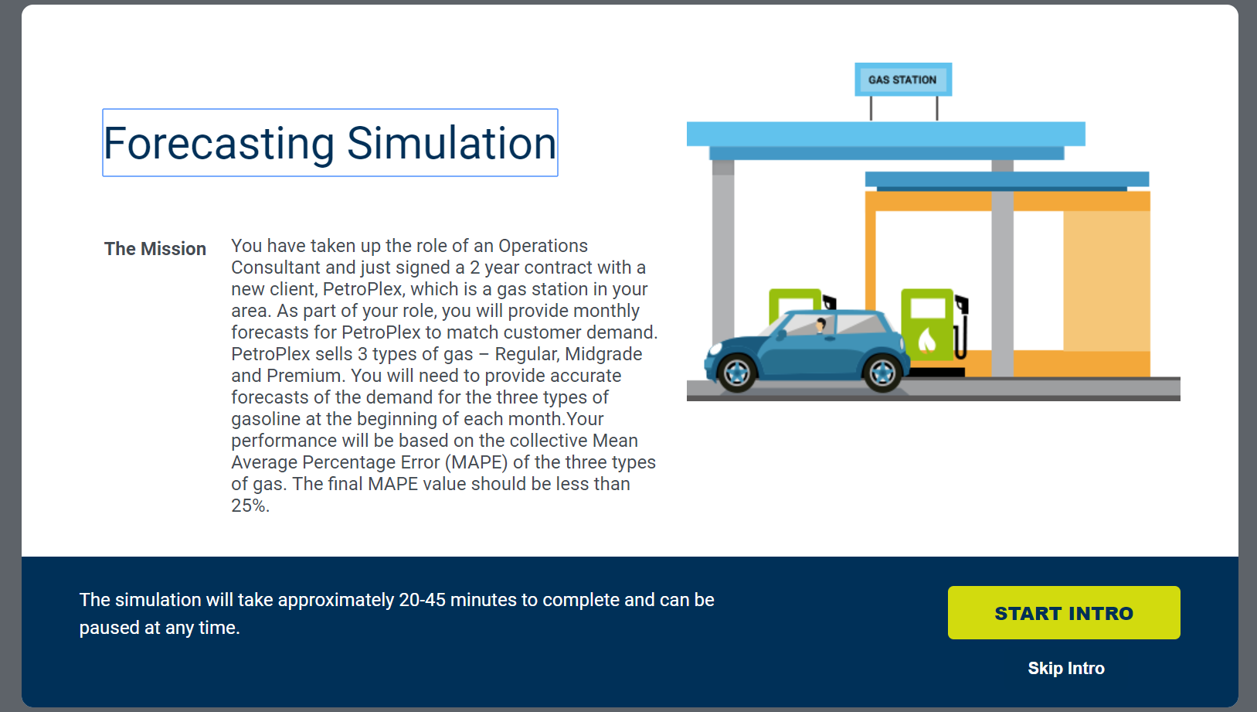

## Summary Screen

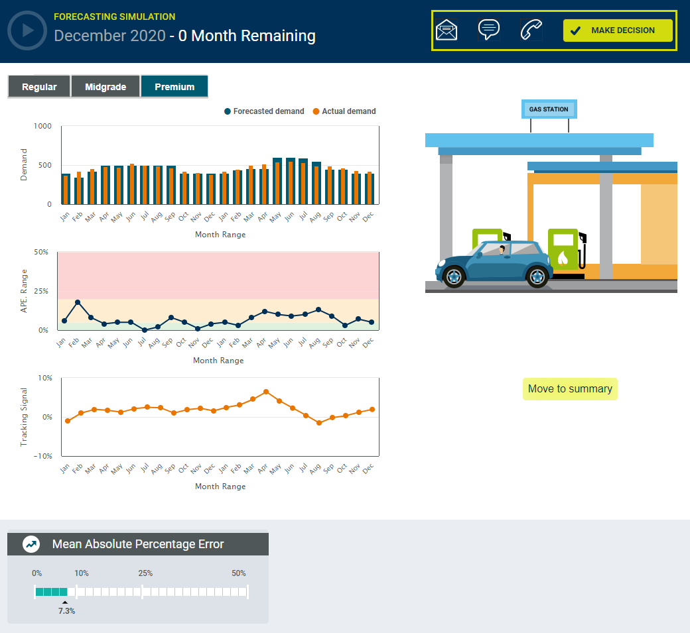

## General Feedback

## 

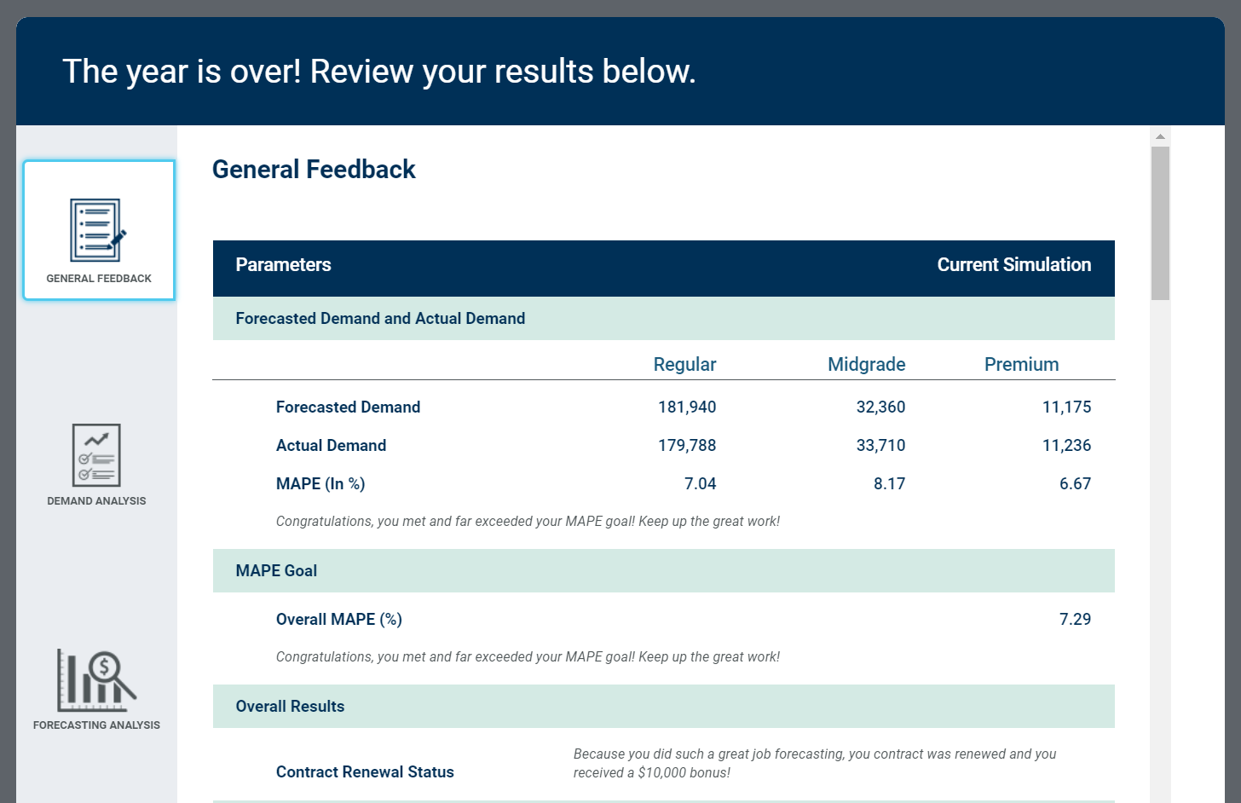

## Demand Analysis

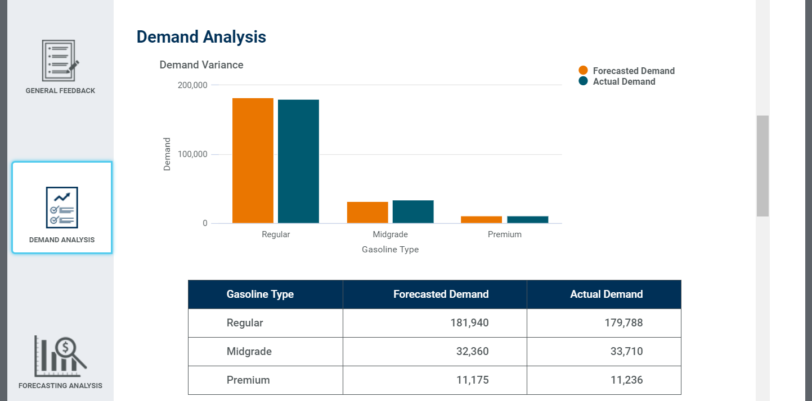

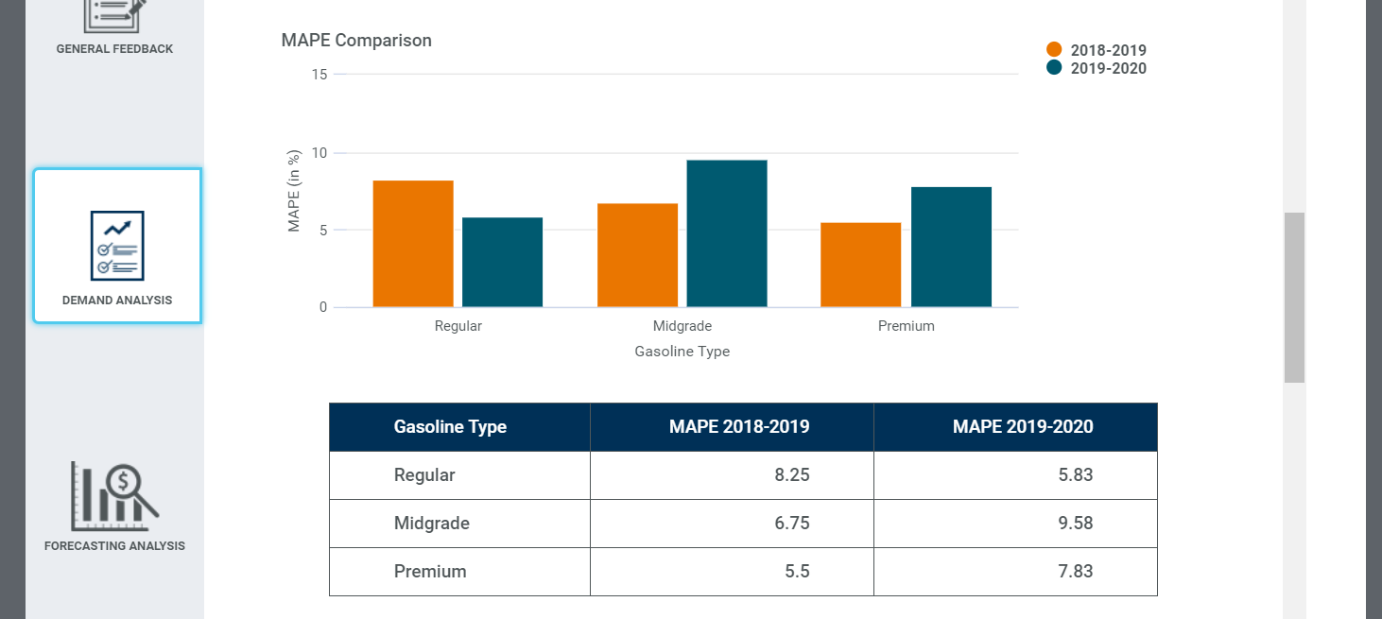

## Forecasting Analysis

